Regression Analysis
- Bivariate Regression Model:
Model: 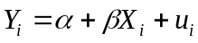
Y = Dependent Variable (e.g. Quantity Demanded)
X = Independent Variable (e.g., Price of the Commodity)
u = Random Disturbance Term
Assumptions on the Random Disturbance Term:
Assumption
Normal distribution of the random disturbance term
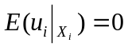
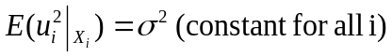
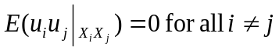
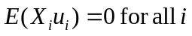

Consequence of Violation of Assumptions
Violation of Assumption | Consequence
The random disturbance term not normally distributed | Statistical tests are not applicable
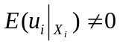 | Biased estimators
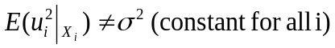 | Problem of Heteroscedasticity - Inefficient estimators
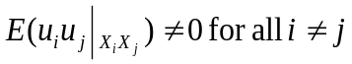 | Problem of Autocorrelation - Inefficient estimators
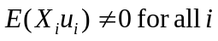 | Problem of Endogeneity - Inconsistent estimators

Method of OLS:

Y Yi PRF
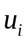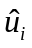
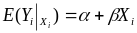
SRF
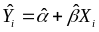

Xi X
Population Regression Function (PRF):
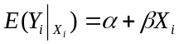
Sample Regression Function (SRF):
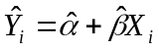
Thus, 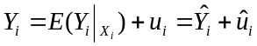
Derivation of the OLS Estimators:
Model:
Objective is to minimize 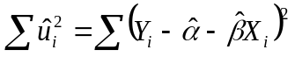with respect to 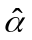and 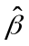
Differentiating with respect to and ,

- 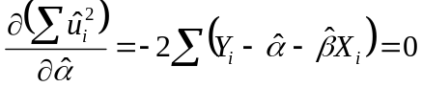 or 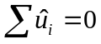 (1)
Similarly, 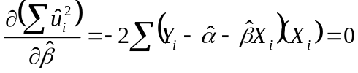 or 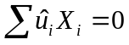 (2)
Solving (1) and (2) for and we get
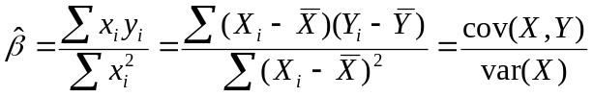 and 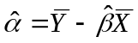
These are the OLS estimators of and
Some Useful Properties:
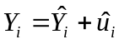
Or, 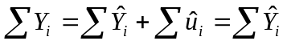 [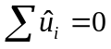]
Or, 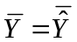 (3)
Now, from (2) we get,
- [as 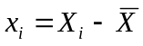and 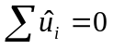] (4)

- [and ] (5)

- [as 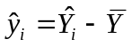] (6)

- [as 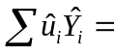0] (7)
- Prove that for the model: , 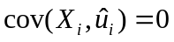 and 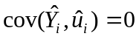
Proof:
[as and ]
[as and 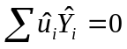]

- For the model if 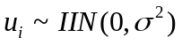, 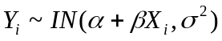
Proof:
(1) Since is a linear transformation ofwith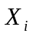being non-stochastic, it will follow normal distribution when does so.
(2) Conditional Mean of :
Thus, the conditional mean of differs across the observations
(3) Conditional Variance of :
(4) Mutual Independence of and 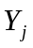:
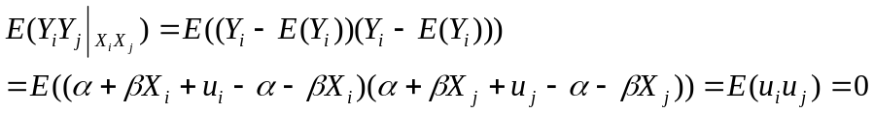
Thus, and are mutually independent
Combining (1) to (4) we get when
- Derive the distribution of and
- Derivation of Distribution of
We have, 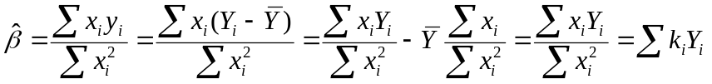 [as 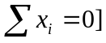
Here, 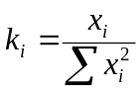such that
(i) 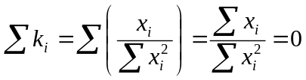 [as
(ii) 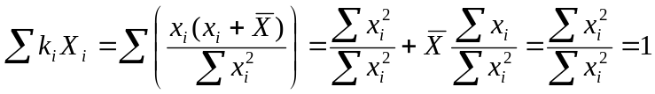 [as 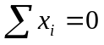;]
Thus, is a linear function of . Since is normally distributed so is (1)
Now,
[as 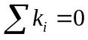 and 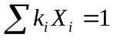]
Hence, 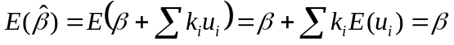 [as 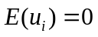] (2)
Further,
[for all 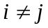]
Hence, 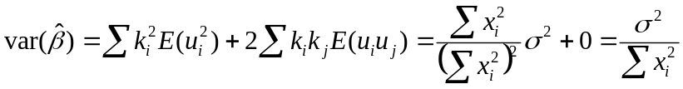 (3)
[as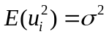; 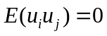and ]
Combining (1), (2) and (3) we get 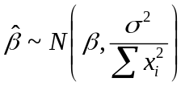
- Derivation of Distribution of
We have, 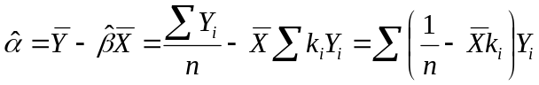 [as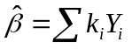]
Thus, is a linear function of . Since is normally distributed so is (4)
Further, 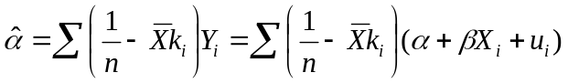
Or, 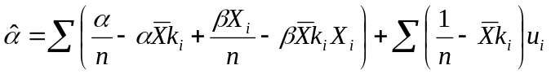
Or, 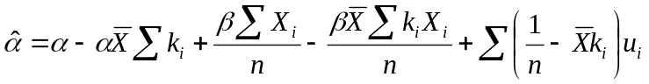
Or,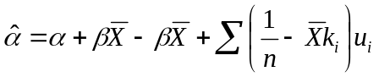 [as 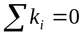and 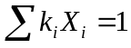]
Or,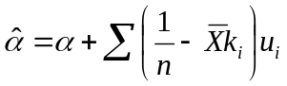
Hence, 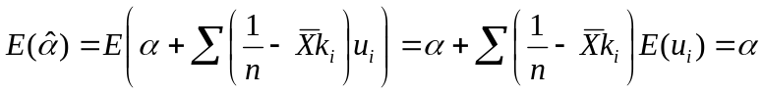 [as ] (5)
Further, 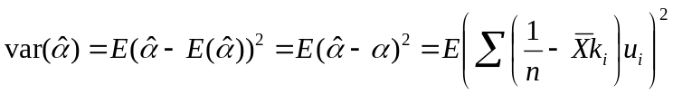
Or, 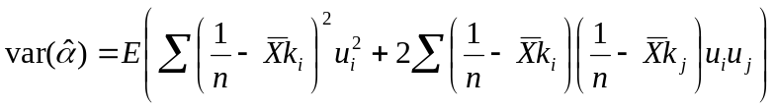 [for all ]
Or,
Or,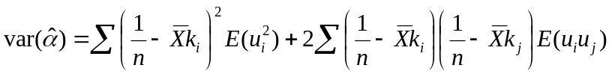
Or,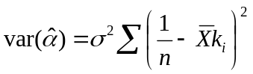 [as 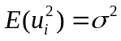and 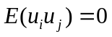]
Or, 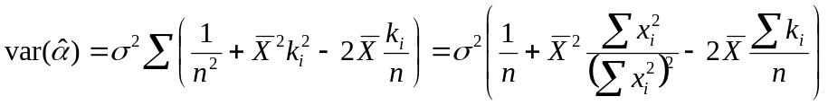 []
Or, 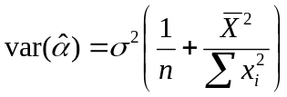 (6)
Combining (4), (5) and (6) we get 